Project Proposal dOCUMENT  Global Optimization using Meta-Heuristics
  Faiza Shanawar | 15140070
  Mohsin Qamar | 15140104
  Haider Ali | 15140101
  Usama Imran | 15140098

Supervisor:

Syed Qamar Askari

Document Information
User
Project | Meta-Heuristics for Global Optimization
Document Version | 1.0
Document ID | AR-01
Identifier | Project Proposal Document
Status | Draft
Authors(s) | Mohsin Khan, Faiza Shanawar
Approver(s) | Syed Qamar Askari
Issue Date

Contents
Document Information 1
1. Problem Statement: 3
1.1. Overview of the problem to be solved: 3
1.2. Meta Heuristics: 3
2. Background and Justification: 4
3. Our proposed work: 4
3.1. Our Idea: 4
3.2. Project Scope: 5
4. Learning Outcomes: 5
5. References: 6

Problem Statement:

Overview of the problem to be solved:
Global Optimization
An algorithm that deals with problems in which a best solution can be represented as a point in an n -dimensional space. The objective of global optimization is to find the globally best solution of (possibly nonlinear) models, in the (possible or known) presence of multiple local optima. Formally, global optimization seeks global solution(s) of a constrained optimization model. Nonlinear models are ubiquitous in many applications, e.g., in advanced engineering design, biotechnology, data analysis, environmental management, financial planning, process control, risk management, scientific modeling, and others. Their solution often requires a global search approach.
Optimal point (0, 0)

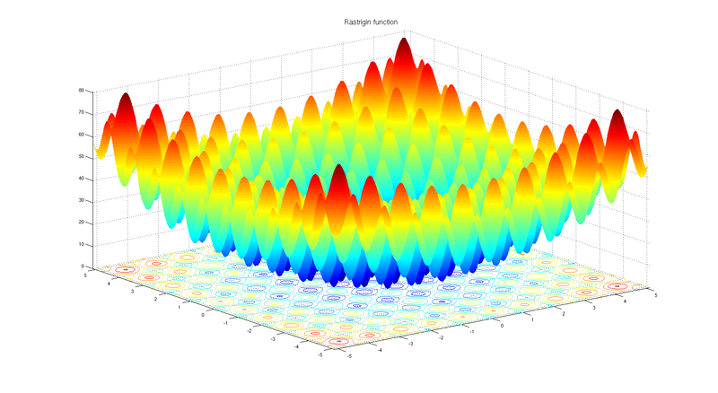

Meta Heuristics:

A metaheuristic is a high-level problem-independent algorithmic framework that
provides a set of guidelines or strategies to develop heuristic optimization algorithms.

This area addresses to find best alternatives among given set of solutions of a particular problem. For this purpose, many optimizations techniques have been developed to find best alternatives. According to our limited knowledge, there is not even a single technique available that can give best solution for all kind of problems. Therefore, different techniques are used to address different problems depending upon their nature. To develop optimization techniques, researchers observe natural phenomenon and convert it into algorithms. One of the prominent examples is Genetic Algorithm which is inspired by biological evolution. Ant Colony Optimization, as the name indicates, is inspired by ant colonies. There are many examples like Gray Wolf Optimization, Particle Swarm Optimization, Gravitational Search Optimization, etc.

Background and Justification:

There are many Nature inspired algorithms that are used to formulate many engineering, medical and industrial problems etc. There is algorithm on Wolves attacking, Dolphin echo-location, Tornedo, Whirlpool, Particle Swarm, Whale, Lion, Cuckoo, Bat etc. As far as we understood from these algorithms, every phenomenon in itself is based on optimization.
These algorithms provoked an idea to design a new algorithm on a phenomenon on which no algorithm has been mapped mathematically. This thought led us to design an algorithm or War Tactics (tactics that are used in Battlefield).
Inspiration of Interface:
The interface of our Application is inspired by Weka. Weka is an open source machine learning comparison tool which compares and displays results of different machine learning algorithms on different data sets and plot the results in tabular and graphs form.
Weka is a collection of machine learning algorithms for data mining tasks. The algorithms can either be applied directly to a dataset or called from your own Java code.
Weka contains tools for data pre-processing, classification, regression, clustering,
association rules, and visualization. It is also well-suited for developing new machine
learning schemes.
In our proposed application, we will add certain algorithms (including our own algorithm) and compare the results based on certain benchmark functions and plot our results in the form of graphs and table.

Our proposed work:

3.1. Our Idea:

We are willing to develop an optimization algorithm. Inspiration we are using is War Tactics. There is no algorithm that is inspired by war tactics according to our knowledge. For that purpose, we will be studying several war tactics and map it into algorithm and then we would compare our algorithm with following well known algorithms:
- Genetic Algorithm
- Particle Swarm Optimization
- Gray Wolf Optimization
- Teacher Learning Algorithm
- Gravitational Search Algorithm
In order to compare our algorithm with above mentioned algorithms, we are willing to develop an application that would be able to compare these algorithms (Above algorithms can be changed). User can choose a particular algorithm and set its parameters and similarly, user can choose second algorithm as well and then their comparison will be shown in tabular and graphs form that includes convergence curves, trajectory. We would also test our algorithm on benchmark functions. (these would be mentioned is SRS document)

Significance of our work
- The proposed algorithm is based on war tactics and war strategies. With the help of our work, many engineering problems like may give optimized solution
- Our work would be shaped into publishable research paper.

3.2. Project Scope:
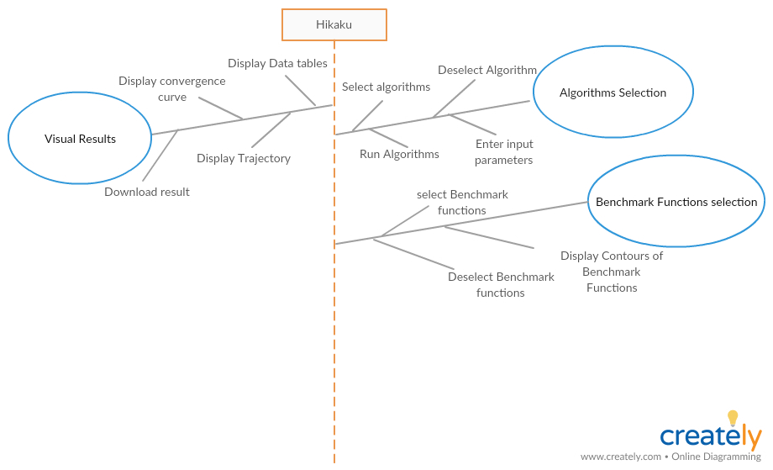

Learning Outcomes:
- We would be able to model real-life problems as optimization problems.
- We would be able to choose a solution method appropriate to the characteristics of a given problem and obtain a solution.
- We would be able to implement optimization methods yields problems in numerical linear algebra.

References:
https://www.cs.auckland.ac.nz/courses/compsci367s1c/tutorials/IntroductionToWeka.pdf
http://mathworld.wolfram.com/GlobalOptimization.html
https://en.wikipedia.org/wiki/Metaheuristic

